. Create IAM Roles
Steps:
- Navigate to IAM → Roles
- Click Create role

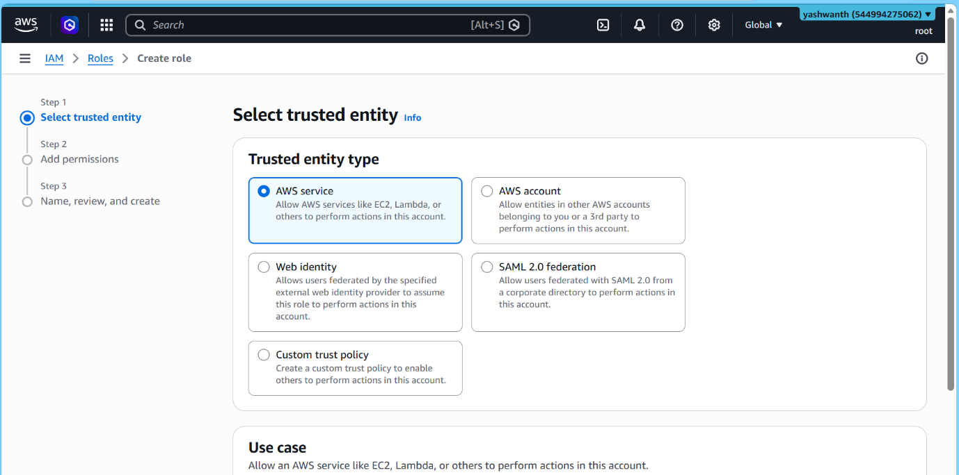

Select Trusted Entity:
Choose based on use case:
- ✅ AWS Service (EC2, Lambda)
- ✅ Another AWS account
- ✅ Web identity (OAuth, SAML)

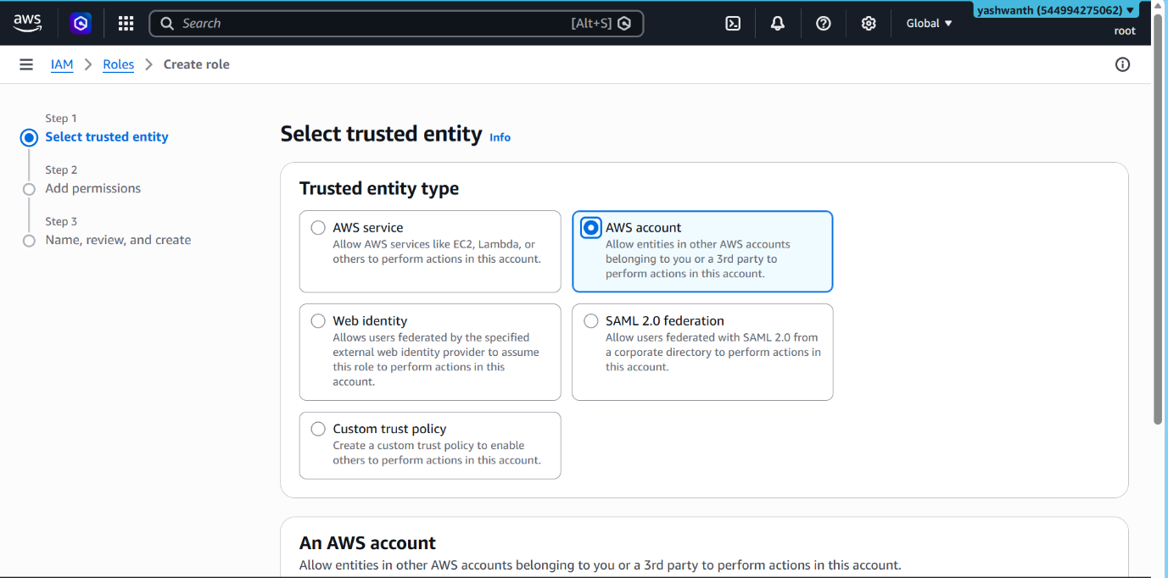
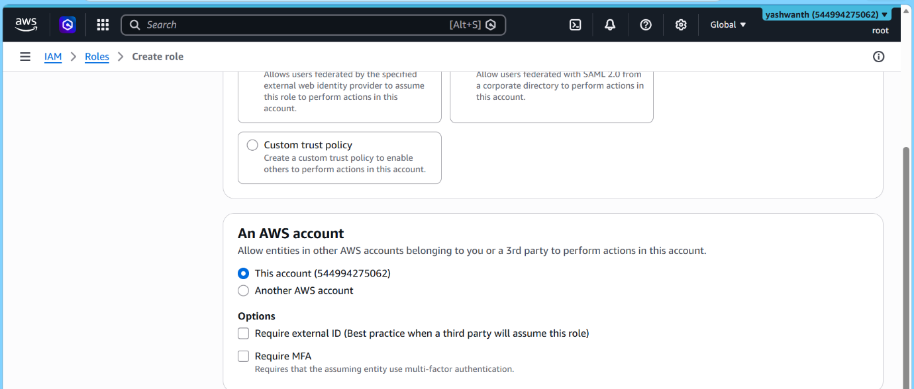

Example: EC2 Role Creation
- Select AWS Service
- Choose EC2
- Click Next

Assign Permissions:
- Attach policy (e.g., AmazonS3ReadOnlyAccess)

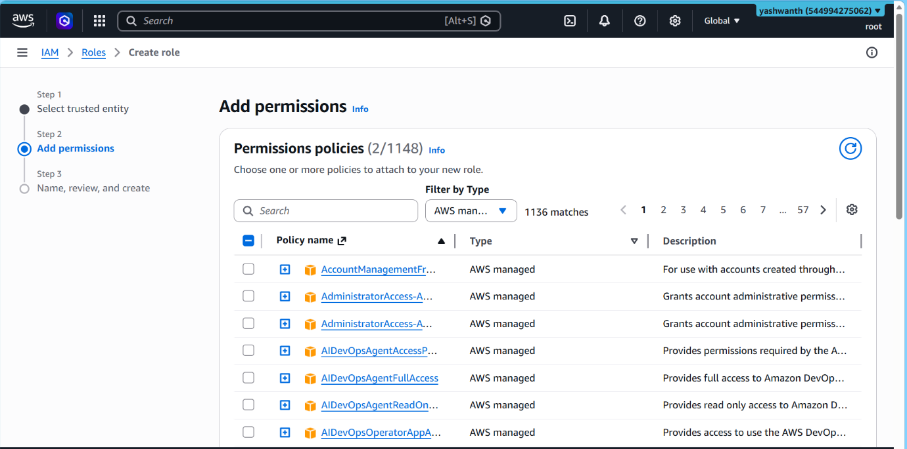

Finalize:
- Enter role name
- Click Create role

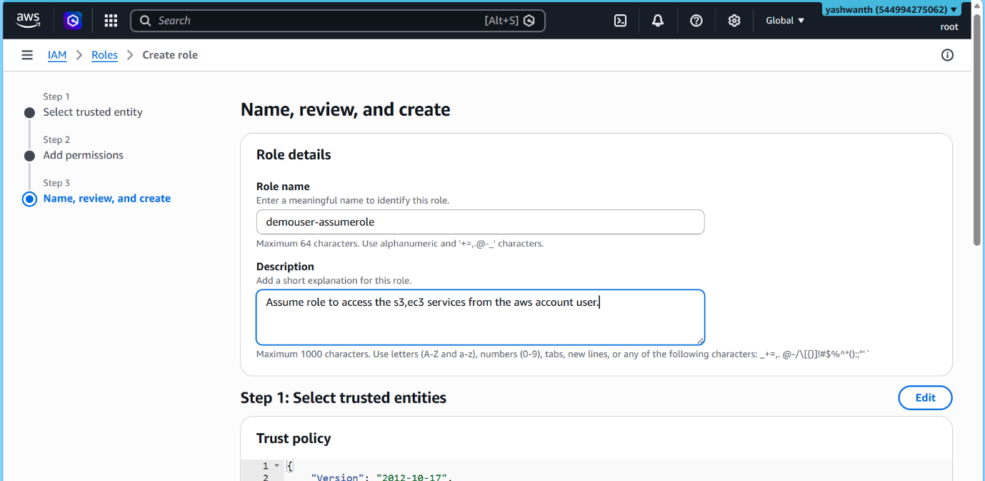

🔗 Attach Role to EC2 Instance
Steps:
- Go to EC2 → Instances
- Select instance
- Click:
  - Actions → Security → Modify IAM Role
- Select created role
- Save

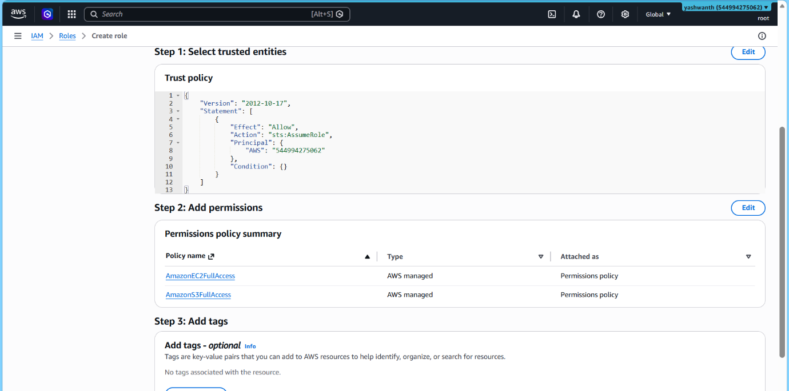

🔒 6. IAM Security Best Practices
- ✅ Never use root account for daily tasks
- ✅ Enable MFA for root & IAM users
- ✅ Use groups instead of individual policies
- ✅ Follow least privilege principle
- ✅ Rotate access keys regularly
- ✅ Enable CloudTrail logging
- ✅ Use roles instead of sharing credentials

